**The Inspection**

The basis of this report is an inspection of the common property areas of the scheme. This report is not an all-encompassing report dealing with the scheme common areas from every aspect. It is a reasonable attempt to identify any obvious and significant defects upon common property areas of the scheme. This report is not a certificate of compliance with respect to any Act, Regulation, Ordinance or By-law. The report is not a structural report and should you require any advice of a

Structural nature we recommend our Structural Engineer be engaged.

The inspection of the common property of the scheme is a visual inspection only limited to those areas of the common property that are fully accessible and visible to the inspector at the time of inspection. The inspection did not include breaking apart, dismantling, removing or moving any element of the building and items located on the common property.

The report does not and cannot make comment upon: defects that may have been concealed; the assessment of which may rely on certain weather conditions; the presence or absence of timber pests; gas fittings; heritage concerns; site drainage; security concerns; detection and identification of illegal building work; durability of exposed finishes; the roof space and under floor space.

The inspector will identify and assess hazards relating to the static condition of the common property and then recommend remedial action or the introduction of a suitable control measure.

This report is not an Asbestos Audit and no assessment of potential asbestos materials is made.

**Purpose of Report**

The purpose of this report is to increase awareness of risk and potential exposures to the property from WHS defects. The report is primarily intended solely for use by Building Manager and the Management Committee (Executive Committee) Recommendations are listed where specific improvements are required to meet relevant standards.

**Disclaimer**

This report has been prepared by [INSERT Building Management Company] and is based on “on-site” inspections. In the circumstances, [INSERT Building Management Company] nor any of its directors or employees give any warranty in relation to the accuracy or reliability of any information contained in this report. [ INSERT Building Management company] disclaims all liability to any party (including any indirect or consequential loss or damage or loss of profits) in respect of or in consequence of anything done or omitted to be done by any party in reliance, whether in whole or partial, upon any information contained in this report. Any party who chooses to rely in any way upon the contents of this report does so at its own risk.

**Priority Key**

Urgency for rectifying the items

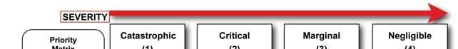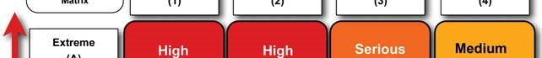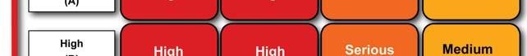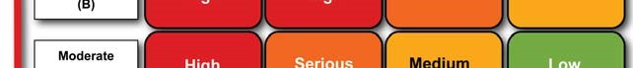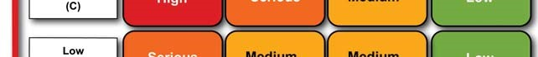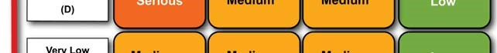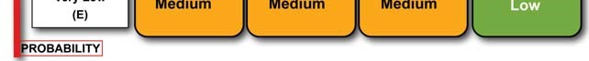

listed below have been classified in this table from very low to extreme

The time line associated in

Rectifying is as follows

1 to 3 days

1 to 2 weeks

1 to 2 months

Negotiable